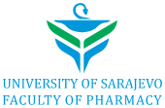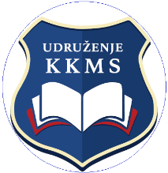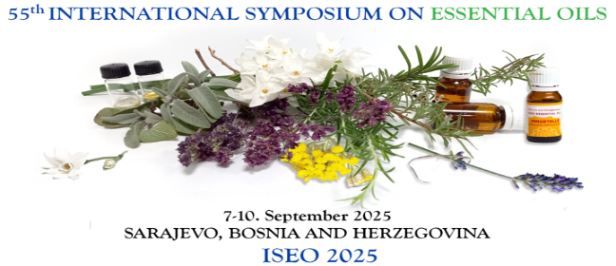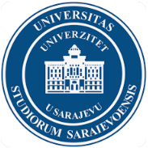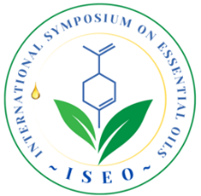

IFEAT- ISEO 2025
The 55th International Symposium on Essential Oils (ISEO 2025) will take place from 7th to 10th September 2025 in Sarajevo, Bosnia and Herzegovina.
The topics of the Symposium will include all aspects of essential oils and related natural products ranging from analysis & characterisation, biogenesis, chemistry, biological activity, residues & contaminants, regulatory aspects and consumer utilisation including recently emerging applications such as aromatherapy, natural cosmetics
Essential oil scientists, producers, users and all other interested persons are cordially invited to register and participate in this 55th International Symposium on Essential Oils (ISEO 2025).
As with the previous successful meetings, ISEO 2025 will include scientific sessions, workshop, exhibition of natural products and essential oils, informative and advertising materials as well as opportunities for business to business exchanges.
In support of ISEO and to encourage the work of young researchers in the field of essential oils, IFEAT typically sponsors up to 38 Young Scientist Fellowships which includes covering of the ISEO conference registration fee. This years ISEO 2025 will include a Plenary Speaker from IFEAT’s Scientific Platform Coordinator, Dr. Jonathan Bonello. Dr. Bonello is also a member of the ISEO Permanent Scientific Committee.
The tradition of awarding the Medal of Honor for lifetime achievements in the field of essential oil and natural complex substances research by the ISEO Permanent Scientific Committee will continue in Sarajevo during the ISEO 2025 event.
Further details and registration are available at the following link: https://www.iseoils.com/info-2025

The deadline for early registration is 15th June 2025.
Please contact scientific.enquiries@ifeat.org with any questions.

